How To

Christoph Vorlen, Daniel Ziegler, Lucas Thiess, Vincent Schauer

**Installation:**

1. **Install Xampp**
2. **Install Sourcetree**

After installation, use Sourcetree to clone the project to a new created folder in the htdocs folder, which is located in the xampp folder. <https://github.com/Vinniento/ratePresentations.git>

Now open the Xampp Control Panel and start Apache and MySQL.

Go to your Browser and open a Tab in Incognito-Mode.

* Type in localhost:8081/foldernameinthehtdocsfolder
* You have to write the number of the port, that is shown in the following figure:



* The name of the folder you created to clone the project must be written at this point

**Database creation and first login:**

1. **Following the rules described in the installation part, follow the link to the database:**

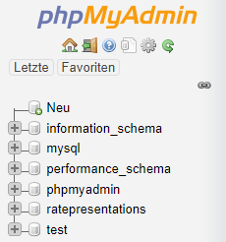<http://localhost:8081/phpmyadmin/>

* Click “New” and create a database with the default settings called “ratepresentations”.
* Secondly add a user “oliver” with a password “nlkj”
* 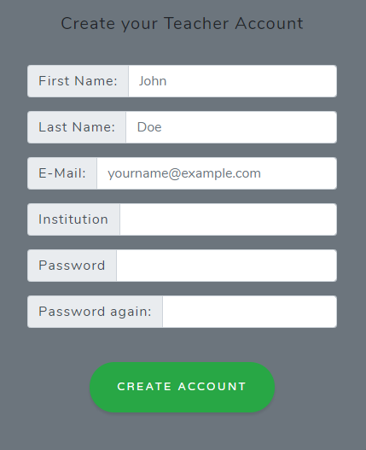After visiting the site in the browser, click login and follow the next button to create an user account – important is that you set the email to [teacher@test.com](mailto:teacher@test.com) and the password to “test” because it already set in the login window. You can chose any other email or password also, though.
* 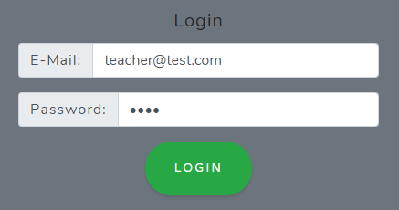Now go to the Login again and enter the details with which you just created the account:

E-Mail: [teacher@test.com](mailto:teacher@test.com)

Password: test

* 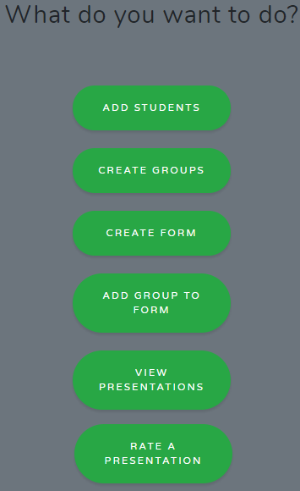After logging in correctly, you can see that you are in the teacher area now. You can use a lot of functions there, which are described on the following pages:

1. **Enable Emails being sent automatically:**

So that the sending of emails after adding a student works properly, you have to add two files into special folders. There is a folder called “mail_send_files” with two files in it: “php” and “sendmail”

* “php” must be copied in the folder xampp/php – overwrite the file inside by copying in the file “php” from the folder “mail_send_files”
* “sendmail” must be copied in the folder xampp/sendmail – override the file inside by coping in the file “sendmail” from the folder “mail_send_files”.

The email we are sending from is: [edmin.ratepresentations@gmail.com](mailto:edmin.ratepresentations@gmail.com)

**Functions – Teacher Area:**

1. **Add Students:**

After clicking the the button “Add Students” a window shows itself:

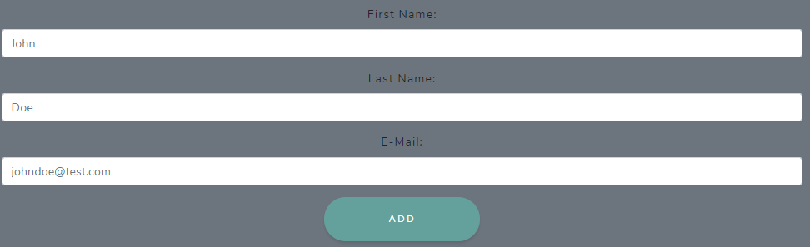

After filling the three fields, the Student is added to the database. The student receives an email with a link – following that link the student gets to a page where he can change his password and create an account for himself. 🡪 The area for students is explained in the next section. **Warning:** The link is set for our local environment. It is possible that you cloned it differently.

1. **Create Groups:**

After pressing the “Create Groups” – Button, a table is shown where all the added students are displayed. They can be selected and a Groupname can be entered, after clicking the create Group-Button, the group is created and saved in the database.

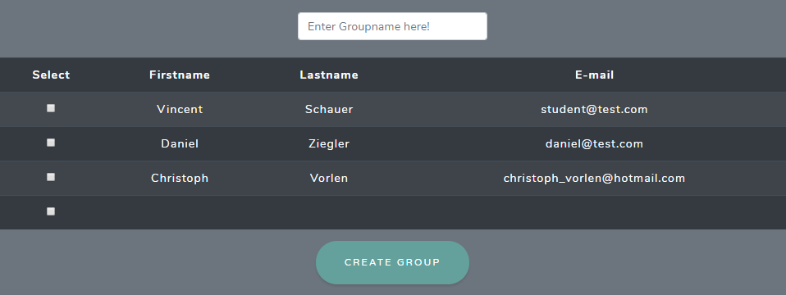

1. **Create Form:**

By Pressing “Create Form”, a survey must be created. This can be used more often for many different groups.

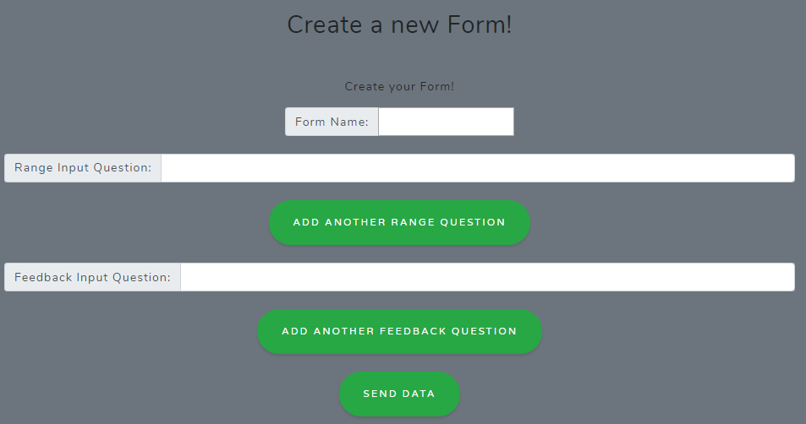

The survey/form must have a name under which it is saved. Range Questions with a Slider can be added. Open Questions with text answers can be added as well – the main goal of this textarea-field is the possibility of given the group additional written feedback.

By clicking the Send Data Button, the form is saved in the database.

1. **Add Group to Form:**

Back in the teacher area, by clicking the “Create Presentation”-Button, a presentation with a certain date can be created.

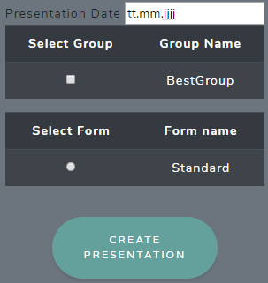

In this case, “BestGroup” is the name of the created group, that has all the selected students in it. The form name “Standard” is the survey/form, that was created before. After selecting a certain date as well, the presentation can be created by clicking the button.

1. **View Presentations:**

After pressing the “View Presentations”-Button, a table of the created presentations is shown. In this case, the Group “BestGroup” was added to two dates. On the right side the rating-code is shown. This code is used to rate the presentation after it was presented – the teacher gives this code to the students.

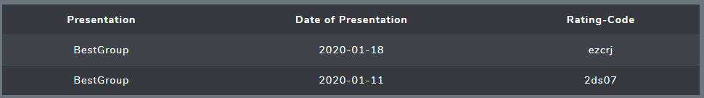

**After all these steps, a presentation can be rated by students and teachers.**

1. **Rate a Presentation:**

The teacher himself can rate a presentation by clicking the button “Rate a Presentation”. The code “2ds07” is entered in this case and the button “rate” is clicked.

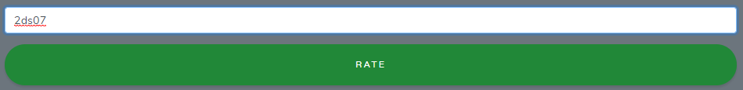

Now the form/survey that is connected to each group through the code is displayed:

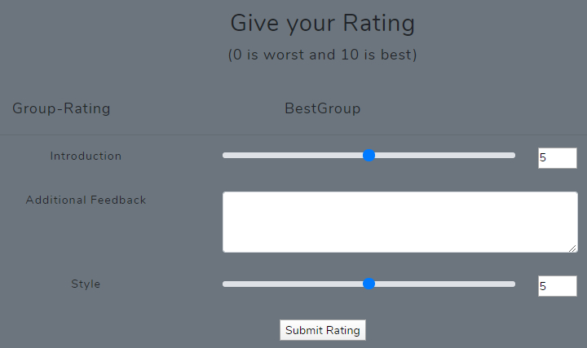

With the slider a number between 0 and 10 can be selected, the textarea can be filled by written text. After the rating is final, the Submit Rating-Button must be pressed and the ratings are sent to the database.

**Functions – Student Area:**

1. **Steps to log in:**

To log in as a student, a password must be manually changed, in case the sending of the email did not work or a dummy mail was entered:

* In our case, we change the password of the student Vincent with the email [student@test.com](mailto:student@test.com) to the password “test”, because by adding the student, a random password is created for the user.
* Open <http://localhost:8081/phpmyadmin/> in the Browser
* Select the database “Rate Presentations” and the table “Students” and go to the column with the name “pwd”
* Change the pwd of [student@test.com](mailto:student@test.com) to (encrypted):

$2y$10$GTgCDDlq4O0lsGNUd6cTBOfEfVr5lcEajpwUj7OZOkFua54fsXLJy

* After changing the password, the student can log in like the teacher with the credentials:

E-Mail: [student@test.com](mailto:student@test.com)

Password: test

1. **Logged in as a Student:**

The student area looks like it is shown in the following picture. Vincent was selected to be part of the group “BestGroup”. The student can view his rating by clicking the button “View Rating”.

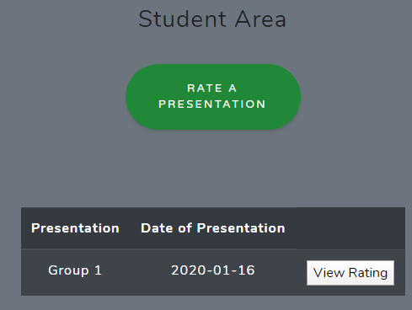

In the following picture the Ratings of the presentations are displayed. The presented ratings are an average of all people who rated the presentation they just saw. This is still faulty though and doesn’t work properly due to SQL statement issues. Text feedbacks aren’t currently displayed either.

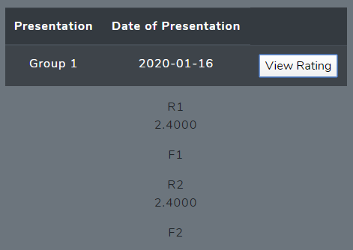

1. **How can the students rate:**

The students rate anonymously, so they just go to the starting page, by clicking on the “Rate Presentations”-Words on the navbar on the top of the page. They enter the code that was given to them and the correct form opens, they rate like the teachers do, just anonymously. The stud

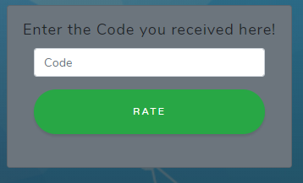

**If you have any problems or questions, just contact us through:** [**edmin.ratepresentations@gmail.com**](mailto:edmin.ratepresentations@gmail.com)

**Moscow Criteria**

**Funktionale Anforderungen**

* **Must Have**
* **Feature zum Erstellen von Gruppen**

Studenten lassen sich bereits in die Datenbank speichern und in einer Tabelle darstellen. Diese Studenten sollen ausgewählt werden können und einer Gruppe zugeordnet werden können.

* **Zufallscode erstellen**

Wenn der erste Punkt funktioniert, soll für eine dargestellte Gruppe, einen ausgewählten Fragebogen/Ratingbogen und ein definiertes Datum ein Zufallscode erstellt werden. Dieser soll für den Lehrenden beim Name der Gruppe und dem Datum dargestellt werden.

* **Logik vom Anzeigen von bewerteten Präsentationen anpassen**

Dieser Teil wurde beim Prototypen hardgecoded und soll vollkommen funktionstüchtig eingebaut werden

* **Bewertungen darstellen**

Auswertung der abgegebenen Bewertungen der Studenten und Lehrenden

* **Should Have**
* Auswertungen der abgegebenen Bewertungen der Studenten und Lehrenden sollten richtig angezeigt werden
* User können Passwörter zurücksetzen
* Website online stellen um diese im großen Rahmen vorzustellen
* **Could Have**
* Präsentationen können in einen Kalender hinzugefügt werden
* **Won’t Have**
* Raumplan der FH Campus – dabei ist gemeint, dass anstehende Präsentationen und der Raum in dem diese stattfinden auf der Website angezeigt werden

**Nicht Funktionale Anforderungen**

* **Must Have**
* Neues modernes Design
* Zufallscodedarstellung – Beschreibung bei funktionalen Anforderungen
* **Should Have**
* Website online veröffentlichen
* **Could Have**
* Website gegen SQL-Injections sicher machen

Nur auf gewisse Seiten zugreifen können, wenn (richtiger/jeweiliger User) eingeloggt